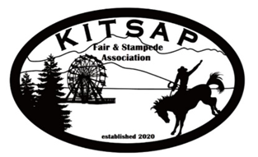
Rich Nestor, Fair Director
nestor.kfsa@gmail.com
Cindy McKay, Admin Assistant
mckay.kfsa@gmail.com

Kitsap Fair and Stampede
August 24-28, 2022
Stadium Advertising Sign Contract / Invoice

☐ New Sign ☐ Renewal

Advertiser: Click or tap here to enter text.

Advertising Includes: Placement of sign for 1 (one) year

Advertiser will provide: Sign (if not a renewal)
We recommend contacting Ace Signs at 360-377-2786

Sign Options (size and cost). Please check one:
☐ 4 x 8 $500.00
☐ 4 x 16 $1000.00
☐ 8 x 16 $1500.00 (Please contact Fair for Availability)

Agreement Date:

The undersigned agrees to pay the amount indicated above to Kitsap Fair and Stampede by or before August 1 of the current year.
Advertiser understands, acknowledges, and agrees that the Kitsap Fair and Stampede is intended to be held in an open-air venue which is subject to inclement weather and other acts of God, as well as civil unrest or other unforeseen events. Advertiser further agrees and acknowledges that, if the event is cancelled for any reason which is out of the control of the Kitsap Fair and Stampede Association, that Advertiser shall not be entitled to the refund of any monies paid for advertising at the event.

Company Name:Click or tap here to enter text. Contact:Click or tap here to enter text.

Mailing Address:Click or tap here to enter text.

Phone Number: Click or tap here to enter text. Email:Click or tap here to enter text.

_______________________________________ Date_________________________________________
Advertiser Signature

